Honors Chemistry Name ______________________________
Review – Matter Period _______

- Name each of the following elements:
P __________________________ Hg __________________________
Cu __________________________ Ca __________________________
I __________________________ Cl __________________________
Mg __________________________ S __________________________
Li __________________________ H __________________________
Si __________________________ Pb __________________________ Zn __________________________
- Write the chemical symbol for each of the following elements:
_______potassium _______aluminum _______sodium _______bromine
_______silver _______carbon _______tin _______ iron
_______oxygen _______fluorine _______ helium _______ nitrogen
- Write 3 facts and draw a particle diagram for each type of matter listed below:
a. Element

b. Compound

c. Solution
(homogenous mixture)

d. Heterogeneous
Mixture

- What does the Law of Definite Proportions state? Which type of matter does this relate most closely to?

- Identify each of the following materials as a heterogeneous mixture (HM), solution (S),
compound (C) or element (E).
carbon dioxide ______ oxygen ______
sodium ______ salt water ______
milk ______ cereal ______
blood ______ smoke ______
pure water ______ sand ______
tap water ______ liquid with a precipitate ______
- What is mass? How is the mass of an object determined?

- Could two objects with the same volume have different masses?
Which, if either, would contain more matter?

- If a compound and a mixture are both a combination of two or more materials/atoms, then aren’t they the same thing? If not, what about them is different?

- What are the three states of matter of most concern to chemists?

- What do we mean by interparticle attractions?
Describe each state of matter in terms of interparticle attractions.

- What is compressibility? Describe each state of matter in terms of compressibility.

- Classify each of the following as physical, (P) or chemical, (C).
_____a) a towel absorbing water _____g) baking a cake
_____b) rusting nail _____ h) boils at 88⁰C
_____c) mothballs subliming _____ i) deflating a basketball
_____d) is blue _____ j) volume
_____e) malleability _____k) sugar dissolving in water
_____f) alcohol evaporating _____l) sewing a hem
- How is a qualitative observation different than a quantitative observation?
Give an example of each.

- How are extensive properties different than intensive properties?
Give 3 examples of each type.

- List the four main observations which indicate that a chemical change has occurred.
- ______________________________________________________
- ______________________________________________________
- ______________________________________________________
- ______________________________________________________
- Name the type substance that sometimes forms when two liquids are mixed together. Describe what this substance looks like (state of matter, etc.).

- Name the following pieces of laboratory equipment:

____________________________ ____________________________
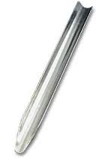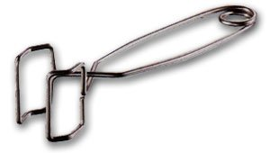

____________________________ ____________________________
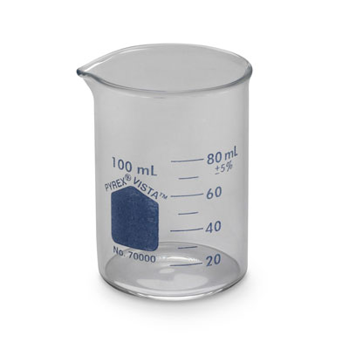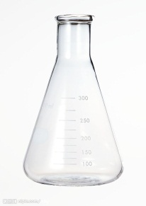

____________________________ ____________________________

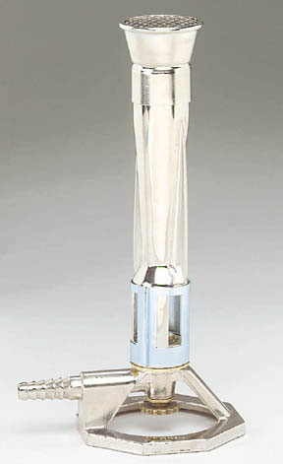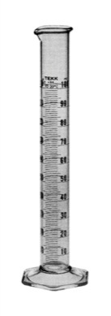

- Draw a concept map (or make a list) to describe each of the 6 phase changes that we discussed in class. Make sure to show both the starting and ending phase for each one.

