Note Guide Name ________________________________
States of Matter

Three states of matter:
SOLIDS
• __________________________________________________
• __________________volume and ______________________ shape
• Particles are ______________________________________________
and vibrate about a ________________________________________
LIQUIDS
• ________________________ than solids, ______________________ gases
• ________________________ volume, ____________________________________shape
• Particles are _________________________________,
but far enough apart to __________________________________________________
GASES
• _________________________________________________________________
• ________________________________volume and ____________________________shape
• Also called __________________ and are ______________________________
• Particles are ________________________________ and _____________________________
The state a material is in or the change in state that occurs to a material depends on:
• the _________________________ (motion) of its particles ….. and …..
• the strength of the __________________________________________________
( ___________________________________________________________)

Changing States of Matter
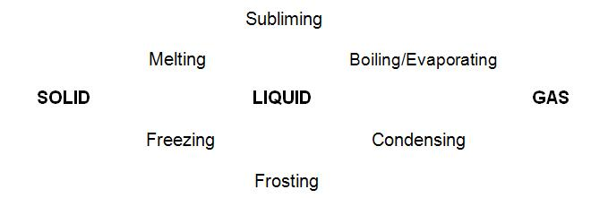
___________________________________ for any change left to right (________________________)
Because the interparticle forces must be overcome.
___________________________________ for any change right to left (________________________)
Because the interparticle forces be allowed to take over.

