Physical Science Name _____________________
Unit 2 Period ___ Date ____________

Physical Science – Unit 2 Review

1. Describe the difference between mass and volume.

2. What are typical units used to measure:

a. distance _______________
b. mass _______________
c. volume (list 2) _______________
d. density (list 2) _______________

3. In the picture of a graduated cylinder shown at right, sketch in a liquid with a volume of 37.0 mL.

4. If the box at left contains atoms of iron in steel wool, represent the
particle structure of the steel wool after strong heating in a fire in the box at right.

5. In the Mass Change Lab, students took an ice cube in a container, massed it, then let the ice cube melt and massed it again. The mass did not change.

a. What concept does this illustrate? ________________________________

b. Draw particle pictures for before and after for this procedure.

Before | After
6. The 1st hour physical science class produced the following graph when they were measuring the mass and volume of a set of objects in the lab.

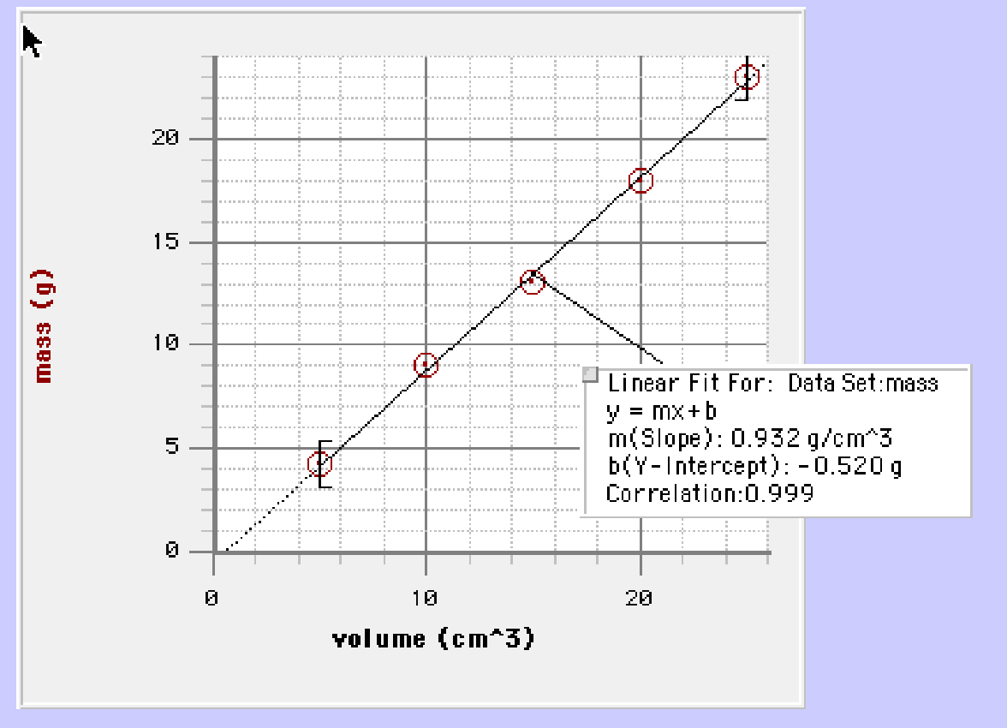

D
C
B
A
E
0 g

a. Write the equation for the line in y = mx + b format.

b. What is the density of this substance? (include units) _________________________

c. What is the volume of a chunk of this substance that has a mass of 42g? Show your work.

7. What is the formula for density? __________________________

8. Mercury has a density of 13.6 g/mL. What is the volume occupied by 112.0 grams of mercury?

9. In Figure 4 below, a graph shows the relationship between mass and volume for two substances,
A and B. Use the graph to answer questions about these two substances.
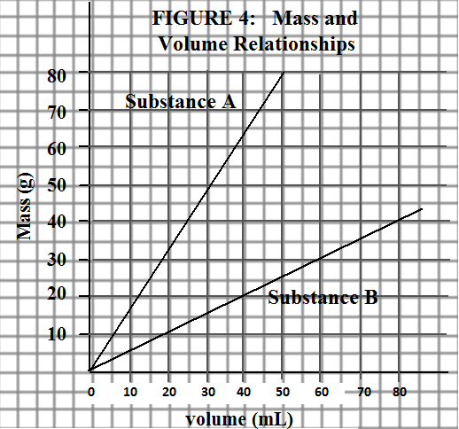

- Water has a density of 1.00 g/mL. Sketch the line
representing water on the graph in Figure 4.

b. Determine whether substances A and B will sink or float
when placed in a bucket of water. (Circle)

A: sink or float

B: sink or float

10. Draw a particle representation for each of the following

A mixture of lead (Pb) and oxygen (O) | A compound of lead (Pb) and oxygen (O)

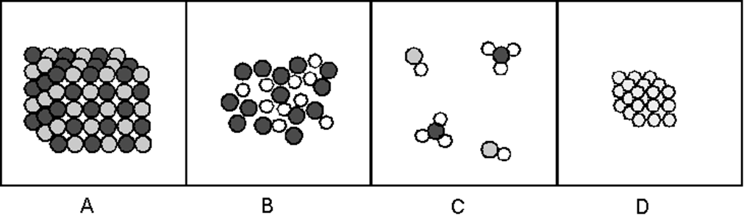

11. Use the pictures above and the definitions discussed in class and from the notes to help you…don’t just think about what they are made of, but how can we separate them as well.
a. Define/describe the difference between element and compound.

b. Define/describe the difference between pure substance and mixture.

12. Pure Substance vs. Mixture

Substance | Pure Substance or Mixture | If pure … Element or Compound | Particle Picture
carbon (C)
salt water
carbon dioxide (CO₂)
water (H₂O)
air
iron (Fe)

13. What is the difference between a dilute and a concentrated solution? Use particle pictures to help
you describe the differences.

14. What are two methods used to separate mixtures? Give at least 1 example of each method.
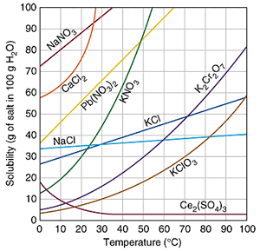
15. How many grams of CaCl₂ are needed to make a saturated solution at 20°C?

16. Which substance is the most soluble at 10°C?
17. At 50°C, can 100 mL of water hold more NaCl or Pb(NO₃)₂?

18. Would you be able to dissolve ( all / some ) of 40g of KNO₃ into 100mL of water at 20ºC?

19. At what temperature would you need 100g of water to dissolve 100g of NaNO₃?

20. List the substances (if any) that decrease in solubility as the temperature increases.

