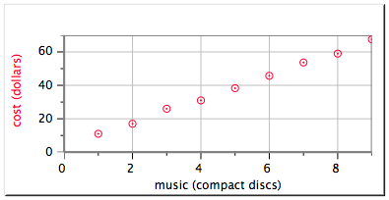
- A friend prepares to place an online order for CD's.

Slope = 7
y-intercept = 3.6

- What are the units for the slope of the graph to the right?

- What does the slope of the graph tell you in this situation?

- Write an equation that describes the graph.
- What is the independent variable? What is the dependent variable? How did you decide?

2. The following times were measured for spheres of different masses to be pushed a distance of 1.5 meters by a stream:
Mass (kg) | Time (s)
5 | 10.2
10 | 17.3
15 | 23.8
20 | 31.0
- Graph the data on Logger Pro. Make sure to include all required components of a graph.
- Write an equation for the graph that describes the data.

- Write a clear sentence that describes the relationship between mass and time.

- Using your line of best fit equation, if you had a mass of 30 kg, how long would it take to travel 1.5 meters? Show work!
- What is the independent variable? What is the dependent variable?

3. Conversions: Complete the following conversions. Make sure to show your work (calculation, fraction, dimensional analysis, substitution, decimal movement, etc.) and use the conversion factors listed below as needed. 1 ft = 12 in 3 ft = 1 yard 1 km = 0.621 miles

a. 150 cg = ___________________ kg b. 12 L = ___________________ mL

c.. 240 in = ___________________ ft d. 300 km = ___________________ miles
4. Measurements in the lab. Using the equipment set up in the lab, measure the following:
- Volume of water in the graduated cylinder

- Temperature of water in beaker

- Length of paper clip

5. Two new forms of currency have recently been circulating in the Bettendorf area. In this new currency system 4 Bulldogs are equal to one Spartan.
a. Visually show this relationship in a diagram.

b. One Bulldog or one Spartan...which one is a larger currency? ________________________
c. To pay for your lunch, would you need more Bulldogs or more Spartans? Explain why.

***Make sure you review all notes, labs, worksheets, and practice problems from Unit 1. Remember, you do have a list of learning targets that you should probably reference while you are studying! :)

