Unit 2 Practice - Worksheet 1 Name _____________ P. _____
Elements, Compounds, and Mixtures

Element | Compound | Mixture
1.  2.  3. | 1.  2.  3. | 1.  2.  3.
3 Examples: | 3 Examples: | 3 Examples:

Classification of Matter Flow Chart

Can be separated by physical means

Can be separated by chemical means
Cannot be separated
Matter Element
Mixture Compound
Homogenous Mixture Atom
Heterogeneous Mixture Molecule
Pure Substance

Unit 2 Worksheet 2 – Element, Compound, and Mixture Name ____________

1. Identify the separation techniques pictured below. Which technique would be useful to separate a mixture of sand and salt? Of salt and water?
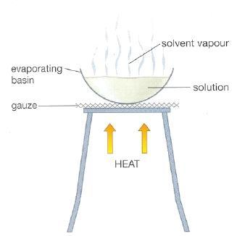
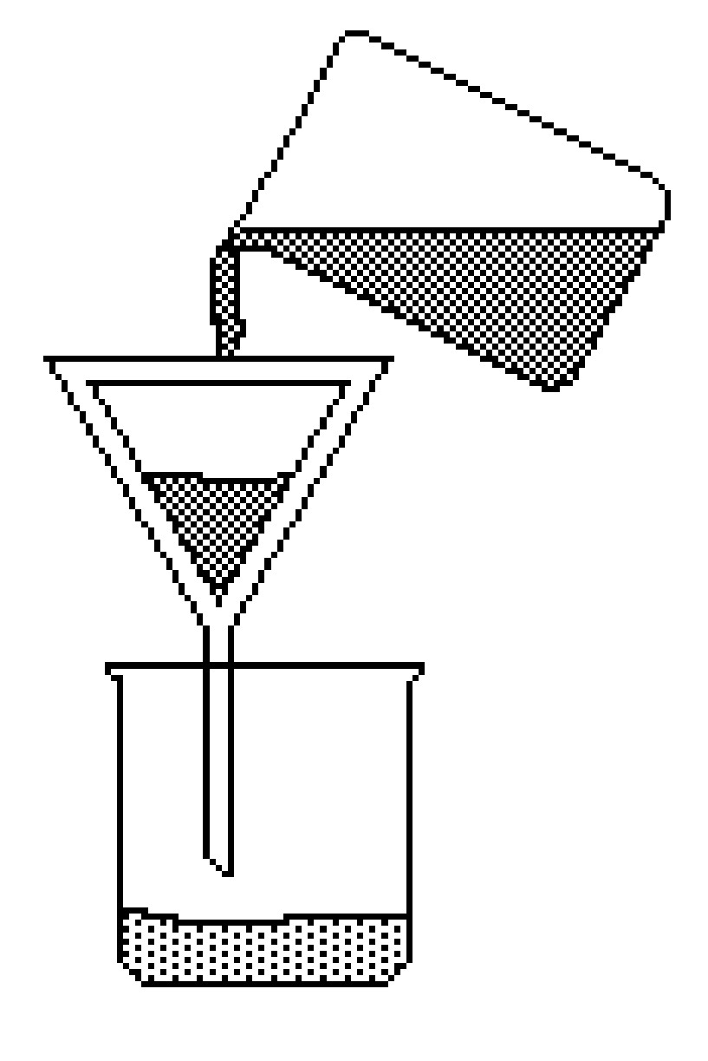

2. Explain why the technique at left would not be effective in separating a mixture of salt and sugar.

3. Draw particle representations for the following:
A mixture of iron and sulfur | A compound of iron and sulfur

4. Explain why a magnet can separate iron atoms from the mixture but not from the compound.

Identifying Elements, Compounds, and Mixtures

5. A mixture (is/ is not) a chemical combining of substances.

6. In a compound the (atoms/ molecules) are (chemically/ physically) combined so that the elements that make up the compound (retain/ lose) their identities and (do/ do not) take on a new set of properties.

7. True or False: A mixture is always made up of a combination of elements.

8. In a mixture, the substances (lose/ retain) their identities.

9. In a mixture the substances involved (can/ cannot) be separated by a simple physical process.

10. In a compound the elements involved (can/ cannot) be separated by a simple physical process because the elements are (physically combined/ chemically bonded).

11. True or False: An element can be broken down into a simpler substance.

12. The smallest identifiable unit of an element is a(n) _____________.

13. Consider the four containers below.
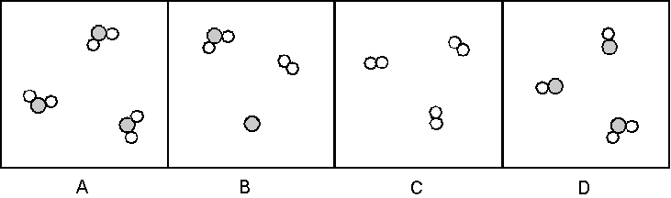
a. Which of these are mixtures? ________________ pure substances? _______________

b. Which contain only compounds?______________ only elements _________________

14. Consider the four containers below.
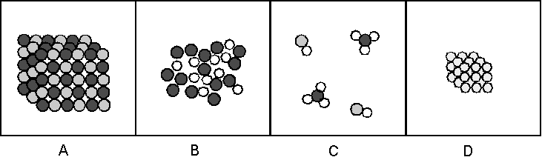
a. Which of these are mixtures? _____________ pure substances? ________________

b. Which contain only compounds? ______________ only elements ________________

15. Consider the four containers below.
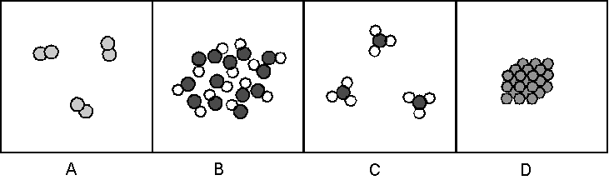
a. Which of these are mixtures? _________________ pure substances? _______________

b. Which contain only compounds? ______________ only elements _________________
16. Which of the containers in #15 contain a gas? ___________ a liquid __________ a solid _________

