Honors Chemistry Name _____________________________
WS Bonding Practice Period ________

1. What are valence electrons?

2. Use the periodic table to find the number of valence electrons in each of these atoms:
a) sodium ____ b) carbon ____ c) bromine ____ d) phosphorous ____

3. Indicate if the value increases or decreases with the given change on the periodic table.
Property | Across row (left to right) | Down column (top to bottom)
Atomic Size
Ionization Energy
Electronegativity

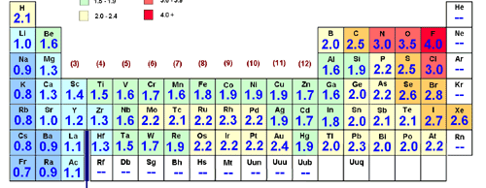
4. Use the chart of electronegativities above to complete this table:
Bonding between: | More electronegative element and value | Less electronegative element and value | Difference in electronegativity | Bond Type  (covalent or ionic)
Sulfur and
Cesium
Chlorine and
Bromine
Calcium and
Chlorine
Oxygen and
Hydrogen
Nitrogen and
Hydrogen
Iodine and
Iodine
Copper and
Sulfur
Hydrogen and
Fluorine
Carbon and
Oxygen
5. Explain how atoms form ionic bonds.

6. Explain how atoms form covalent bonds.

7. For each of the following:
Lewis structure Shape Bond angles

a) NCl3

b) OF2

c) NH4+

d) AsCl3

8. Mothballs are compose of naphthalene, C₁₀H₈, a molecule that consists of two six-membered rings of
carbon fused along an edge, as shown in this Lewis structure.

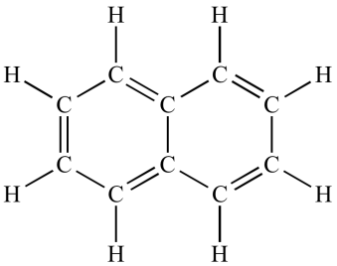

a) Draw all of the resonance structures of naphthalene in the space above. How many are there?

b) Do you expect the C – C bond lengths in the molecule to be similar to those of C – C single bonds,
C = C double bonds, or intermediate between the single and double bonds?

c) Not all of the C – C bond lengths in naphthalene are equivalent. Based on your resonance
structures, how many C – C bonds in the molecule do you expect to be shorter than the others?

9. Write electron configurations and orbital diagrams for the following then fill in the blanks.
(Hint: The number of covalent bonds can be predicted by the number of half-filled orbitals.)
a) Fluorine
Electron configuration:
Orbital diagram:
Fluorine has ____ valence electrons
Fluorine has ____ half-filled orbital(s) and makes _____ bond(s) in compounds.

b) Oxygen
Electron configuration:
Orbital diagram:
Oxygen has ____ valence electrons
Oxygen has ____ half-filled orbital(s) and makes _____ bond(s) in compounds.

c) Nitrogen
Electron configuration:
Orbital diagram:
Nitrogen has ____ valence electrons
Nitrogen has ____ half-filled orbital(s) and makes _____ bond(s) in compounds.

D) Carbon
Electron configuration:
Orbital diagram:
Carbon has ____ valence electrons
Carbon has ____ half-filled orbital(s) and you would think it makes _____ bond(s) in compounds.
BUT … carbon atoms form four bonds. How can this be? How can it get four half-filled orbitals??

