Physical Science Name ________________________
Unit 1 Period ___ Date _______________

Demonstrating Lab Skills
- Measuring length with rulers and meter sticks:
- Find the length of the room in meters. _______________________m
- Convert the length to centimeters, then kilometers. show your work.

______________________cm ___________________km
- Find the width of the room in meters. ___________________m
- Convert the width to cm, then kilometers

______________________cm ___________________km
- Find the area of the floor in the room in square meters, then square centimeters. Show your work. Area = length x width

_____________________m² = ___________________cm²
- Find the length of the longest edge of the provided objects using a ruler. Then, convert the lengths measured to the units provided in the last column.

Object | Length You Measured (____) | Converted Length
 |  | _____ km
 |  | _____ m
 |  | _____ dm
 |  | _____ hm
 |  | _____ mm

- Measuring mass with an electronic balance:

Before turning on the balance, make sure it is on a flat, stable surface and that the balance is clean.

Never place a chemical directly on the balance pan! A container such as a weigh boat must be used. Place the container on the balance and the mass of the container will be displayed. By pressing the Zero/Tare button at this point, the balance will reset to zero and ignore the mass of the container. Avoid bumping the balance once it has been zeroed.

You may now place the substance to be massed into the container and the balance will show only the mass of the substance. This saves calculation time and effort. However, when the container is removed from the balance, the display will go into negative numbers until the Zero/Tare button is pressed again. If the balance is not working properly, inform your teacher.

Each time you mass a substance you must Zero/Tare the balance so that the display reads 0.0

Sketch and label the features of an electronic balance.

Practice. Mass and record the masses of 5 objects. Use a weigh boat for your objects. Don’t forget to tare! Convert the masses measured to the units provided in the last column.

Object | Mass You Measured (____) | Converted Mass
Beaker |  | ______ kg
Pen |  | ______ cg
Tongue Depressor |  | ______ dg
Test Tube Clamp |  | ______ hg
Penny |  | ______ mg

3. Measuring the volume of a liquid with a graduated cylinder:
When measuring liquid volume it is important to read the graduated cylinder correctly. The surface of a liquid confined in a cylinder curves to form what is known as a meniscus. The meniscus of most liquids curves up the sides of the container, making the center of the curve appear lower than the edges.

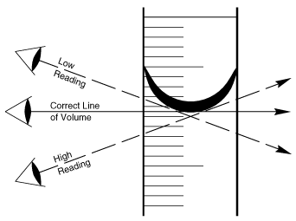
Since reading the meniscus at the top or at the bottom of the curve will make a difference in the volume measured, it is generally agreed to always read the bottom of the curve. Place the graduated cylinder on a flat surface and bring your eye level to the bottom of the meniscus.

Practice. Read the 100mL and 50mL graduated cylinders to the nearest ½ mL. (That is, your measurement will end in either .0 or .5) Read the 10 mL graduated cylinder to the nearest tenth (.1) of a mL. Then, convert the volumes measured to the units provided in the last column.

Graduated Cylinder | Volume You Measured (______) | Converted Volume
#1 |  | _________ kL
#2 |  | _________ cL
#3 |  | _________ dL
#4 |  | _________ hL
#5 |  | _________ L
Water Displacement  Drop a small object into a graduated cylinder | Volume before:  Volume after:  Vol. of object: | xxxxxxxxxx  xxxxxxxxxxxxxxxxxxxx

4. Reading a thermometer:

First notice the scale on the thermometer. Are the increments (lines) counting by 1, 2, 5 etc? Once you have determined the scale simply read the thermometer. Your eye should be level with the liquid in the thermometer. You will experience the same errors with a thermometer as with a graduated cylinder if you look from above or below the liquid. When reading the thermometer you should be estimating the last digit.

Also note: many times you will be using the thermometer in a hot liquid thus the thermometer will also be hot. Remember: hot glass looks like cold glass and hot metal looks like cold metal.

Sketch and label the features of an lab thermometer including the scale.

Practice. Read a thermometer under 3 different conditions. Record the temperature to the tenth of a degree (0.1). Let thermometer adjust to the new condition for 2 minutes before reading. Include units! Then, convert the temperatures measured to the units provided in the last column.
$°C=\frac{5}{9}(F-32)$ $°F= \frac{9}{5} C+32$

Condition | Temperature You Measured (℃) | Converted Temperature (℉)
Hot
Cold
Room Temperature

5. Lighting a Bunsen burner:

After the hose is attached to the gas outlet, turn the handle on the outlet parallel to the nozzle to open the gas valve. Turning the handle 90 degrees in either direction turns off the gas valve.

Carefully check to see that you hear gas escaping from the mouth of the burner tube. When you are sure that you have gas, bring the head of the striker over the burner and squeeze the striker handle. (ONLY THE STRIKER IS NEAR THE BURNER NOT YOUR HEAD!) The spark produced will ignite the gas and your burner is lit.

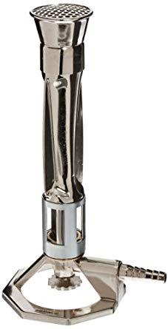

Adjust the air control vent so that the flame has the proper color. A yellow flame is an indication of a lack of oxygen, meaning that the air vent needs to be opened.

The hottest part of the burner flame is just at the top of the bright blue inner cone. Normal heating is done with an object at the top of the light blue outer cone, while strong heating is done with an object at the top of the bright blue inner cone. To heat a container gently, move the container back and forth through the outer cone.

Practice. Both seconds, TURN OFF THE GAS!! Wait 20 seconds and try again.

