Unit 4 Objectives and Study Guide Name _______________________ P _____
(4.01) I can distinguish between a pure substance and a mixture
(4.02) I can apply the properties of matter to identify or describe substances
(4.03) I can evaluate lab techniques used to separate mixtures
(4.04) I can separate the components of a mixture based on their properties using lab techniques
(4.05) I can differentiate between elements and compounds
(4.06) I can identify the names or symbols of common elements
(4.07) I can predict the chemical formula of a compound and the ratio of its combining elements

- You’re conducting an experiment with a mixture of two liquids, liquid A and liquid B. You find the boiling point of liquid A to be 95ºC and the boiling point of liquid B to be 110ºC. Both are colorless liquids. Liquid A has a noticeable odor while liquid B has no odor. Liquid A melts at 5ºC while liquid B melts at -75ºC.
  - Describe the method you would use to separate the two liquids? Name this separation technique. What property is used to separate the liquids?

  - Sketch a graph of temperature vs. time that supports the property used to separate liquid A and B.

2) Be sure to review all vocabulary terms and separation techniques discussed on the note pages. When would you use each separation technique?

- Draw a particle representation for each of the following
A mixture of lead (Pb) and oxygen(O) | A compound of lead (Pb) and oxygen (O)

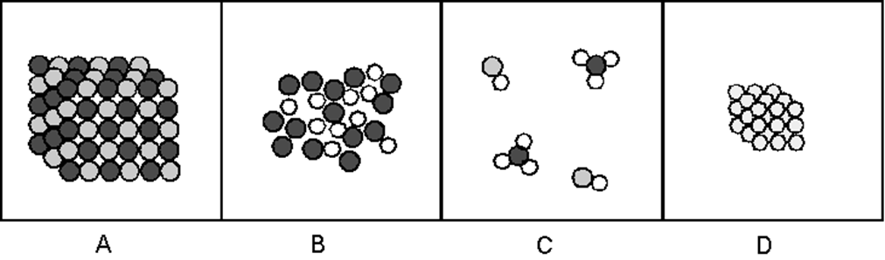

Use the pictures above and the definitions discussed in class and from the notes to help you…
- Define/describe the difference between element and compound.

- Define/describe the difference between pure substance and mixture.

- Suppose one volume of gas A reacted and combined with three volumes of gas B to form one volume of product at the same temperature and pressure. Sketch particle diagrams for gas A, B, and the product assuming gas A and B are monoatomic.
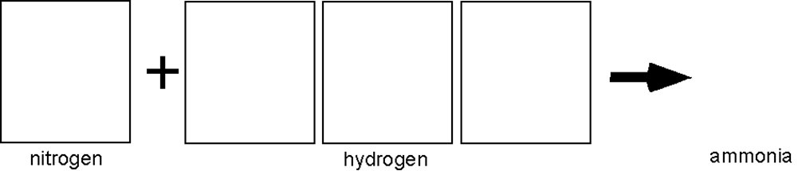

Gas A Gas B Product

- How would the amount of product formed in the above question change if the gases were diatomic?

Pure Substance vs. Mixture Application

Substance | Pure Substance or Mixture | If pure…Element or Compound | If mixture…Homogeneous or Heterogeneous | Particle Picture  Choose any 6 you like and label them
Copper
Carbon
Saline (salt) solution
Carbon dioxide – CO₂
Water – H₂O
Wax – C₆H₁₄
Sugar – C₁₂H₂₂O₁₁
Air
Steel
Salt - NaCl
Iron oxide – FeO
Dirt

Separating Mixtures
Directions: Explain in detail how you would separate the following mixtures in the most efficient way.

(1) Sand + Salt + Iron filings | (2) Ethanol + Water | (3) 5mm BBs + 8mm BBs + 10mm BBs
(4) Rice + Salt + dried mixed beans | (5) Styrofoam peanuts + ping pong balls + loose gravel + sand | (6) Salt and water but keep the water

